Faculty

Web Guide

Omni CMS



**Copyright © 2021 KSU Division of University Information Technology Services** This document may be downloaded, printed, or copied for educational use without further permission of the University Information Technology Services Division (UITS), provided the content is not modified and this statement is not removed. Any use not stated above requires the written consent of the UITS Division. The distribution of a copy of this document via the Internet or other electronic medium without the written permission of the KSU - UITS Division is expressly prohibited.

**Published by Kennesaw State University – UITS 2021**

The publisher makes no warranties as to the accuracy of the material contained in this document and therefore is not responsible for any damages or liabilities incurred from UITS use.

**Table of Contents**

Introduction 4

Learning Objectives 4

Logging into Faculty Web 5

Fixed Layout 8

Editing a Page 9

Accessing the In-Line Editor 11

The WYSIWYG Editor 12

Adding Hyperlinks 13

Adding a Link to an External Site 13

Adding a Link to an Internal Page 14

Uploading Files 17

Adding an Image 22

Inserting YouTube Videos 26

Embedding Videos from Kennesaw State MediaSpace 28

Publishing a Page in Omni CMS 32

Adding Office Hours 34

Creating a New Page in Omni CMS 35

Deleting Pages 37

Deleting Pages from the Recycle Bin 38

Restoring Pages from the Recycle Bin 39

Versioning 40

Viewing an older version of your web page 40

Comparing an Older Version of the web page with the current version 41

Reverting to an Older Version of your web page 42

Editing the Navigation Bar 44

Checking Out Pages 47

Additional Help 48

# Introduction

*Faculty Web* is a useful web content management system that provides easy access to update your faculty web content. With its easy accessibility, WYSIWIG (What You See Is What You Get) toolbar, and other features, *Faculty Web* allows you to publish, manage, and organize a wide array of content for your website.

# Learning Objectives

The following topics are covered in this document:

* Accessing your site for editing
* Becoming familiar with the WYSIWIG editor
* Editing Existing Pages
* Creating New Webpages
* Deleting/Recycling Existing Pages
* Version Control

# Logging into Faculty Web

With the *Faculty Web* *DirectEditor,* you can navigate to your webpage and access the page for editing. The following explains how to access the *Faculty Web* *DirectEditor* in order to edit webpages.

1. In an internet browser, navigate to<http://facultyweb.kennesaw.edu/>.
2. Enter your name in the search bar (See Figure 1).
3. Click the Search Faculty Webpages button (See Figure 1).
4. From the list of results, click your name (See Figure 1).

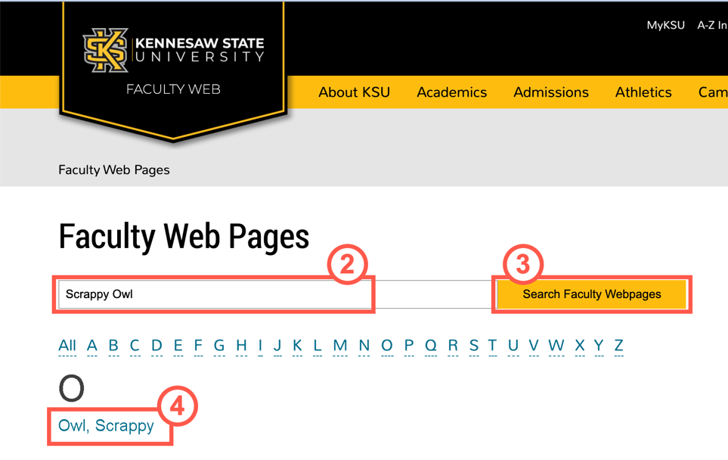

**Figure 1 – Enter Name, Search, and Select**

1. You will be redirected to your page. Click the **DirectEdit** button at the bottom of the page.

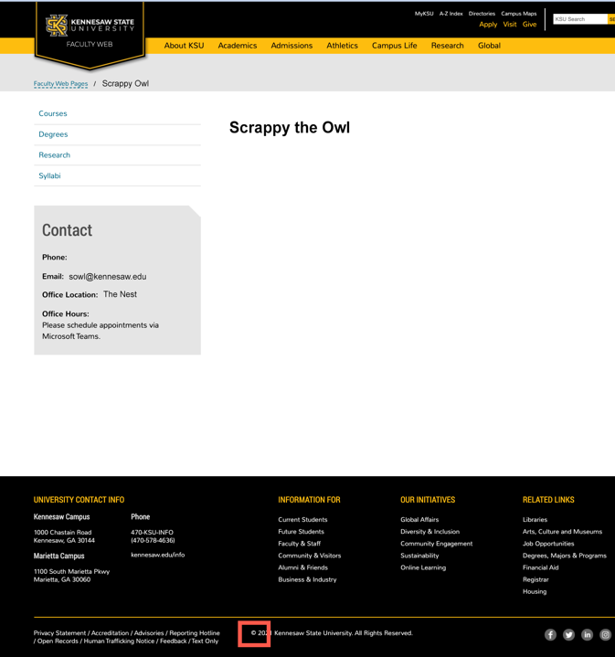

**Figure 2 - Navigate to Page & Click DirectEdit Symbol**

**Note:** The *DirectEdit* button appears as the copyright symbol.

1. Log in with your **NetID** and **NetID password** (See Figure 3).
2. Click **Sign In** (See Figure 3).

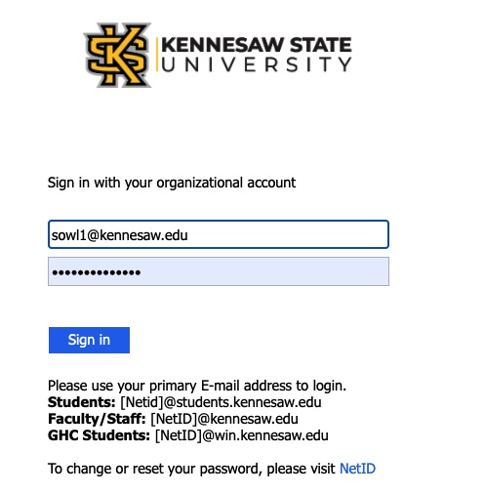

**Figure 3 - Enter NetID & NetID Password**

**Note:** If you are logged into your email through Office 365, you may be automatically logged in to *Omni CMS*. If you automatically log into *Omni CMS*, skip to Step 9.

1. If prompted, use your preferred method to authenticate your account through DUO.

**Figure 4 - Authenticate with DUO**

1. You will be taken to the *DirectEdit* page.

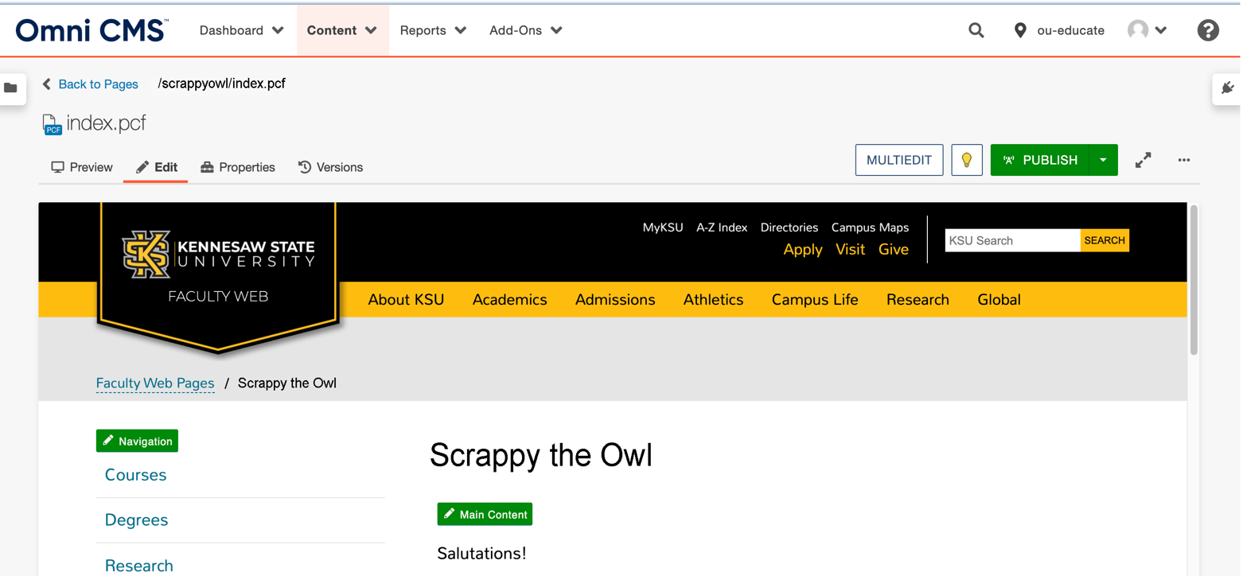

**Figure 5 - DirectEdit Page**

# Fixed Layout

At the top of the page, you will find the static menu that orients you to where you are in your site. Use these buttons to navigate from individual pages to the full site directory.

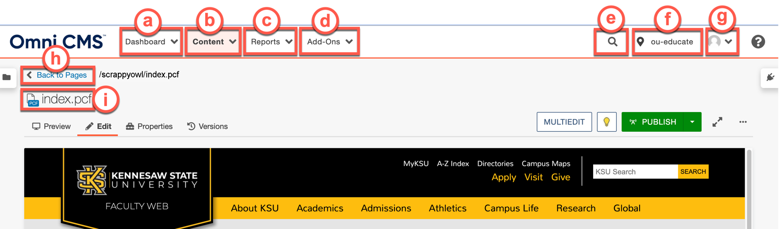

**Figure 6 - Fixed Layout**

1. **Dashboard Tab:** Click this menu for direct access to your dashboard, which contains your *Omni CMS* inbox and widgets to indicate your checked out pages and a history of the activity on sites you have access to (See Figure 6).
2. **Content Tab:** Click this tab to access the menu with links to your site directory, assets, and the recycle bin (See Figure 6).
3. **Reports Tab:** Click to open the menu and access reports for your *Required Actions, Checked-Out*

*Content, Pending Approvals, Scheduled Actions, Recent Saves,* and *Recent Publishes* (See Figure 6).

1. **Add-Ons Tab:** Click to access the *Omni CMS Quick Guide* (See Figure 6)
2. **Search Function:** Use the search function to find content within your site (See Figure 6).
3. **KSU Site Directory:** Displays *ou-educate* for Faculty Web (See Figure 6).
4. **User Profile Menu:** Click your profile picture to access your settings and log out of *Omni CMS* (See Figure 6).
5. **Back to Pages:** Clicking this link redirects you to the site directory (See Figure 6).
6. **Page Name:** The name of the page you are currently editing (See Figure 6).

# Editing a Page

When you are in the *DirectEdit* page, you will have the ability to edit your webpage, preview your page, view page properties, check in/check out of your page, and view various versions of your webpage. The layout of the *DirectEdit* page is as follows.

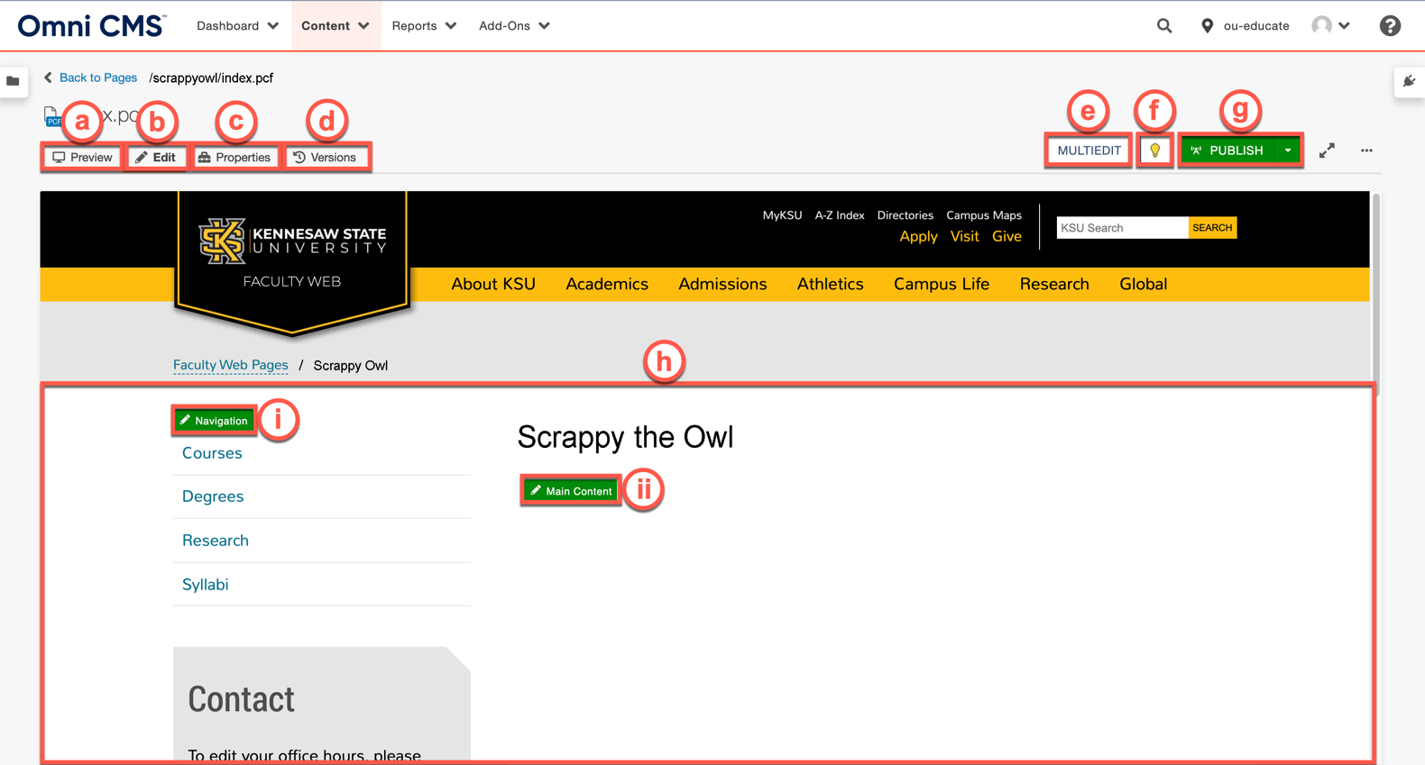

**Figure 7 - DirectEdit Page**

1. **Preview Tab:** Preview your web page as it would appear live on the web (See Figure 7).
2. **Edit Tab:** Add, remove, and make changes to content in the editable regions of the page (See Figure 7).
3. **Properties Tab**: Edit the page properties and view the page editing logs (See Figure 7).
4. **Versions Tab:** View the history of changes to the page and revert to previous iterations (See Figure 7).

**Note:** The *Versions* tab will only be visible if the page is checked out to you (See Figure 7).

1. **Multiedit Button**: Click to edit your office hours in the left column (See Figure 7).
2. **Lightbulb Icon:** Click the button to check in or check out the page (See Figure 7).
3. **Publish Button:** Publish the page to the public live on the web (See Figure 7).

**Note:** If you do not have access to publish the page directly, your changes will need to go through an approval process, and this button will appear as *Submit*.

1. **Editable Area**:
2. **Navigation Button:** Click this button to open the in-line editor to make changes to the site navigation (See Figure 7)

ii. **Main Content:** Click this button to open the in-line editor to make changes to the main area of the page (See Figure 7).

## Accessing the In-Line Editor

The *In-Line* editor allows users to make in-place edits to the webpage. The following explains how to access the *In-Line* editor:

1. In the *DirectEdit* page, click on the **Main Content** button.

­­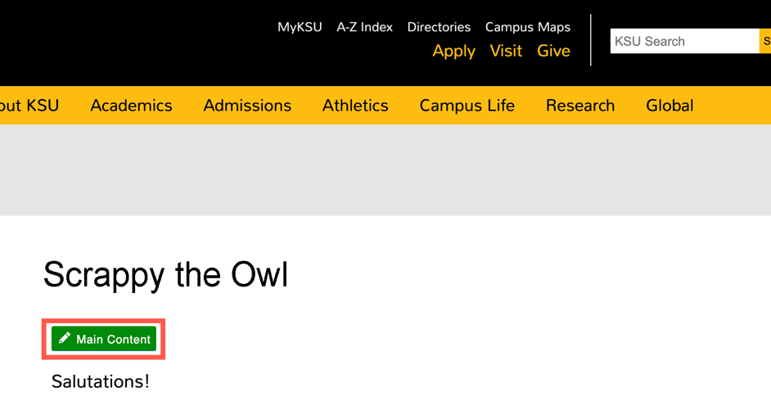

**Figure 8 - Main Content**

1. You will be taken to the *In-Line editor* where you will be able to add/edit text as well as access the WYSIWYG (What You See Is What You Get) editor.

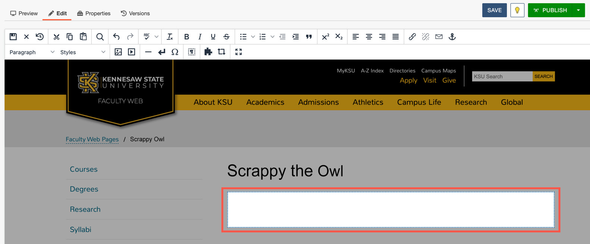

**Figure 9 - In-Line Editor**

1. Begin typing in the text field or use any of the functions in the WYSIWYG menu. See more about the WYSIWYG menu functions in the next section.

## The WYSIWYG Editor

The WYSIWYG editor is your way to edit pages quickly and easily using tools you are likely already familiar with. The WYSIWYG editor layout is as follows:

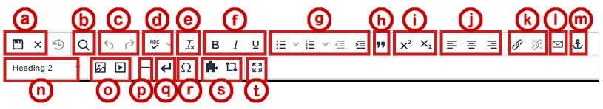

**Figure 10 - WYSIWYG Editor**

1. **File Functions**: Save or revert changes on a page (See Figure 10).
2. **Find Functions:** Find specific content on your page (See Figure 10).
3. **Undo Redo:** Undo/redo changes made on a page (See Figure 10).
4. **Spell Check:** Run spell check on the content (See Figure 10).
5. **Clear Formatting:** Remove all selected text formatting and return text back to the default settings for a page (See Figure 10).

1. **Basic Font Properties:** Format selected text to bold, italic, and/or underline (See Figure 10).
2. **List & Indent:** Create an ordered list or indent content (See Figure 10).
3. **Block Quote:** Format the selected text as a block quote (See Figure 10).
4. **Superscript/Subscript Text**: Format selected text to a superscript or subscript format (See Figure 10).

1. **Alignment Functions:** Move selected text alignment (left, center, right) (See Figure 10).
2. **Link Tools:** Insert/edit links to files or other internal and external pages (See Figure 10).
3. **Insert/Edit Mail Link:** Insert and Edit a *Mailto* link (See Figure 10).
4. **Anchor Tool:** Create an anchor that can be used as a hyperlink on the page (See Figure 10).
5. **Paragraph/Font Styles Options:** Define paragraph style and add site-specific font styles (See Figure 10).

1. **Insert Images/Media:** Add/edit images and videos on the page (See Figure 10).
2. **Horizontal Line:** Insert a horizontal line (See Figure 10).
3. **Insert Line Break:** Insert a line break (See Figure 10).
4. **Special Symbols:** Insert symbols and special characters (See Figure 10).
5. **Insert Snippets and Assets:** Opens a window to place snippets or assets on the page (See Figure 10).

**Note:** For more information on Snippets and Assets, visit the [Omni Training page.](https://omni.kennesaw.edu/training/)

1. **Enter Full Screen:** View the page in full screen (See Figure 10).

# Adding Hyperlinks

When adding hyperlinks to your page, it is recommended that you either copy/paste the link or type the link into the hyperlink fields. The following explains how to add hyperlinks into your website.

## Adding a Link to an External Site

1. In the webpage you are editing, select the **text** that you wish to hyperlink (See Figure 11).
2. Click on the **Insert/Edit Link** button (See Figure 11).

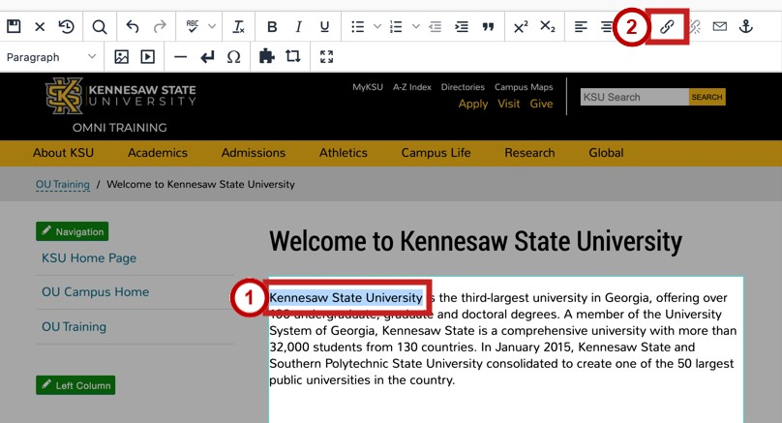

**Figure 11 - Insert/Edit Link**

1. Paste your **link** into the *URL*field (See Figure 12).
2. The *Text to Display* field is the text that is displayed for the hyperlink. If you have selected text prior to clicking on the *Insert/Edit Link* button that text will appear in this field (See Figure 12).
3. If you wish to have the link open in a new window, select **New window** in the *Open link in…* field.

Otherwise, leave the setting *Current window* to have the link open on the same page (See Figure 12).

1. Click **Save** (See Figure 12).

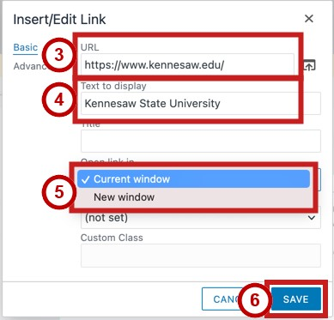

**Figure 12 - Insert Information & Click Save**

1. If you receive a *The URL you entered seems to be an external link* pop-up, click **YES** to add the required **http://** prefix.

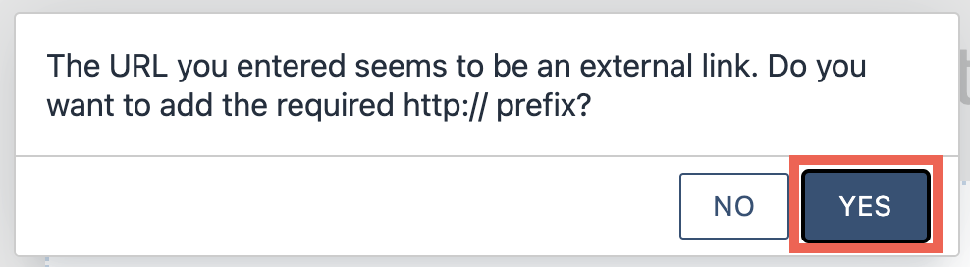

**Figure 13 - Click YES**

1. Your hyperlink will be added to your page.



**Figure 14 - Hyperlink View**

## Adding a Link to an Internal Page

1. In the webpage you are editing, select the **text** that you wish to hyperlink (See Figure 15).
2. Click on the **Insert/Edit Link** button (See Figure 15).

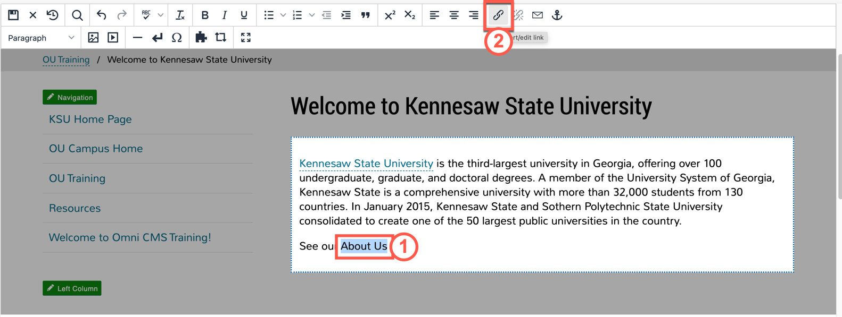

**Figure 15 - Select Text & Click Edit/Insert Link Icon**

1. Click the **Source** Icon.

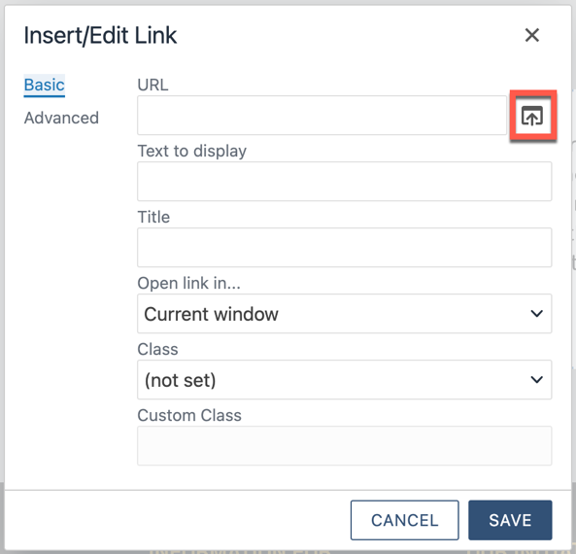

**Figure 16 - Click Source Icon**

1. Navigate the content from your site in the left panel. Select the **page** you wish to link to (See Figure 17).
2. Click **Insert** (See Figure 17).

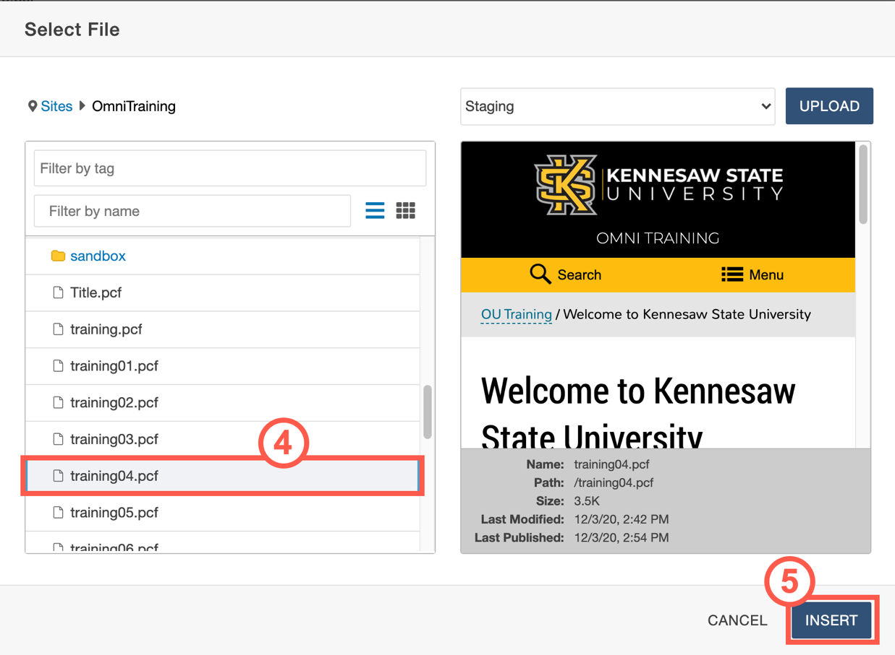

**Figure 17 - Select Page & Click Insert**

1. If you wish to have the link open in a new window, select **New window** in the *Open link in…* field. Otherwise, leave the setting *Current window* to have the link open on the same page (See Figure 18).

1. Click **Save** (See Figure 18).

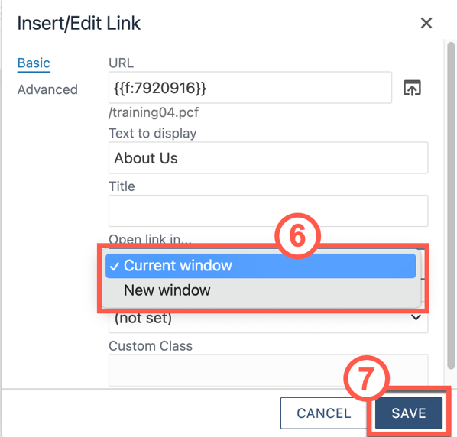

**Figure 18 - Select How Link Opens and Click Save**

1. The hyperlink will be added to the page.



**Figure 19 - Hyperlink is Added**

## Uploading Files

The following explains how to upload files into your website.

1. In the webpage that you are editing, click the **Main Content** button to open the text field.

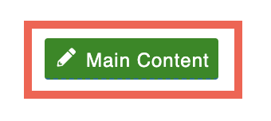

**Figure 20 - Main Content**

1. Place your **cursor** where you wish to add your file link (See Figure 21).
2. Click **Insert/Edit Link** icon (See Figure 21).

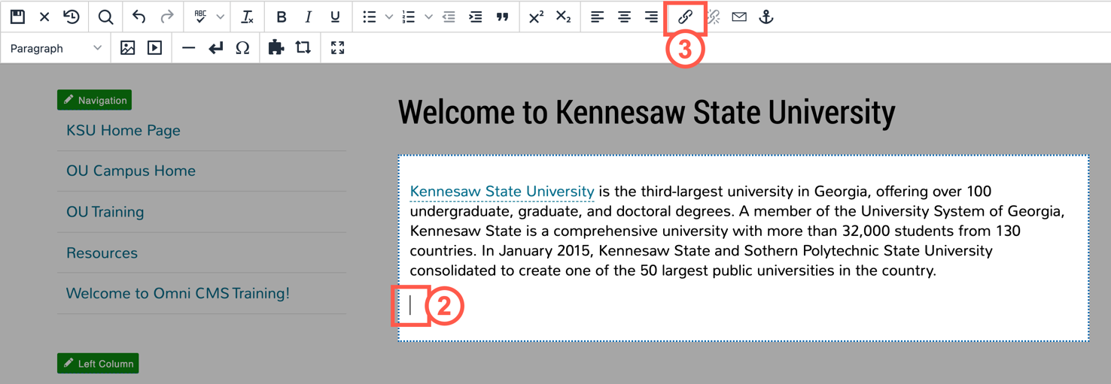

**Figure 21 - Click Insert/Edit Link**

1. Click the **Source** icon.

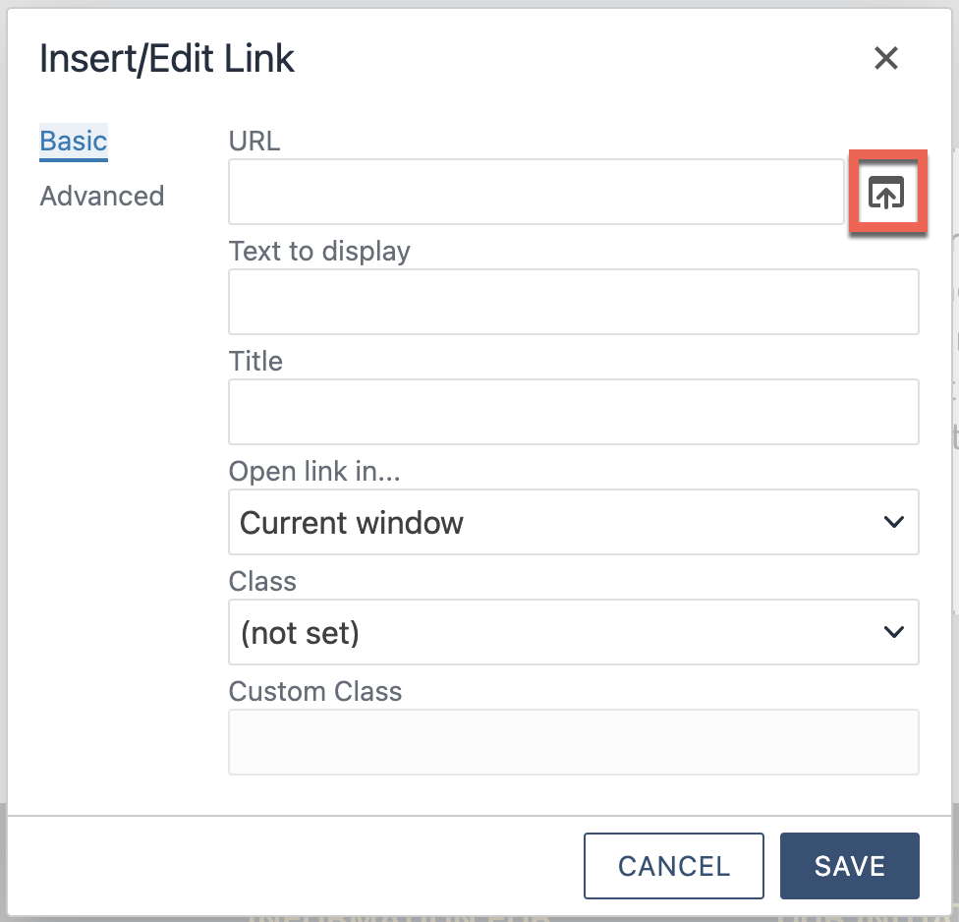

**Figure 22 - Click the Source Icon**

1. The *Select File* window will open. From here, you can either:
   1. Select a **file** from your existing files (See Figure 23).
   2. Click the **Upload** button to upload a file (See Figure 23).

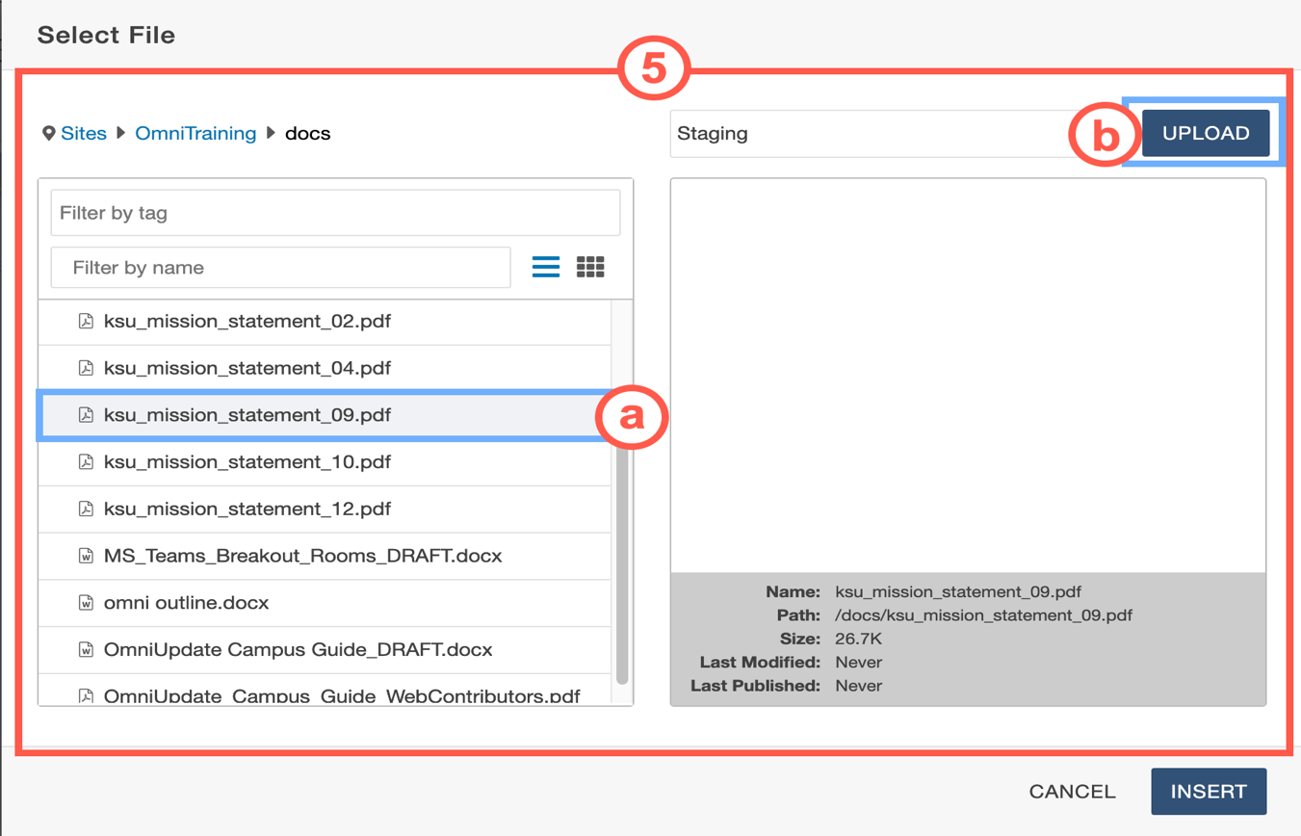

**Figure 23 - Select a File or Upload**

**Note:** If you select an existing file, you can skip to Step 10.

1. Click the **Add** button.

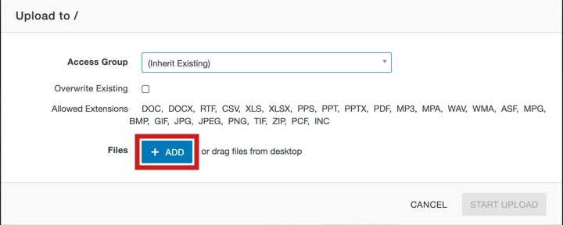

**Figure 24 - Add Files**

1. Navigate to and select the **file** you wish to upload (See Figure 25).
2. Click the **Open** button (See Figure 25).

**Figure**

**25**

**-**

**Select the File**

**& Click Open**

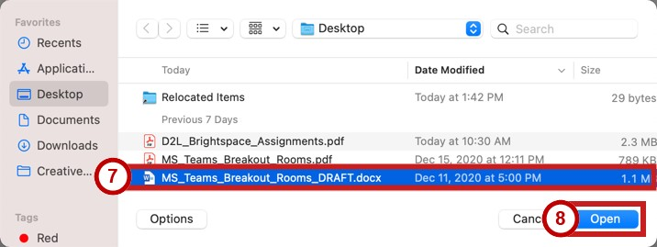

1. You will be returned to the *Upload to* window. Verify that the file is correct and click **Start Upload**.

**Figure**

**26**

**-**

**Start Upload**

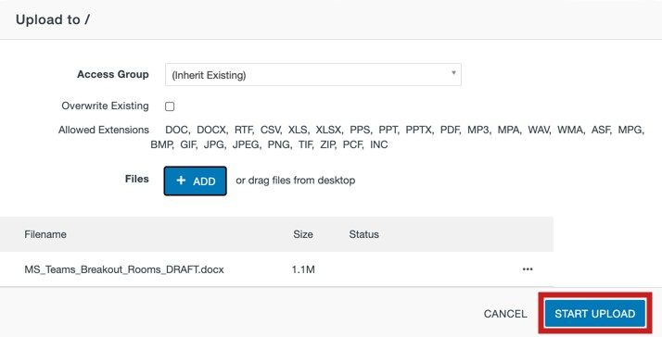

1. You will be returned to the *Select File* window, and the file will appear in the list to the left. Click **Insert**.

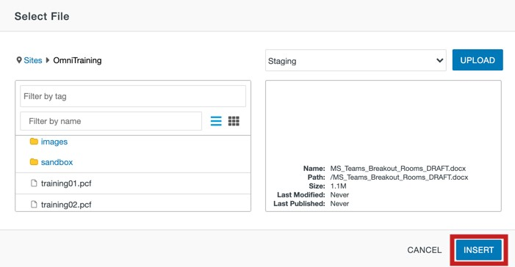

**Figure 27 - Click Insert**

1. Add descriptive text in the *Text to display* field (See Figure 28). **Note: Text in this field will be displayed on your page.**

1. In the *Open link in…* dropdown, select whether you wish to have the file open in the same page or in a new window. Selecting **Current Window** will have the file open in the same browser window. Selecting **New window** will open in a new browser window (See Figure 28).

1. Click **Save** to insert the link on the page (See Figure 28).

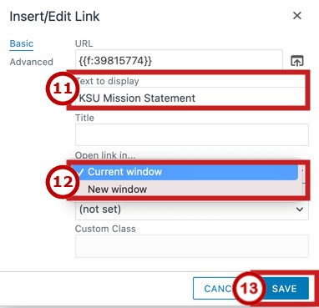

**Figure 28 – Verify Text to Display, Select How Link Opens, & Click Save**

1. Your file and file link will be added to your webpage.



**Figure 29 - Linked File**

## Adding an Image

The following explains how to add an image to your page.

1. Place your **cursor** where you wish to add your file link (See Figure 30).
2. Click on **Insert/Edit Image** icon (See Figure 30).

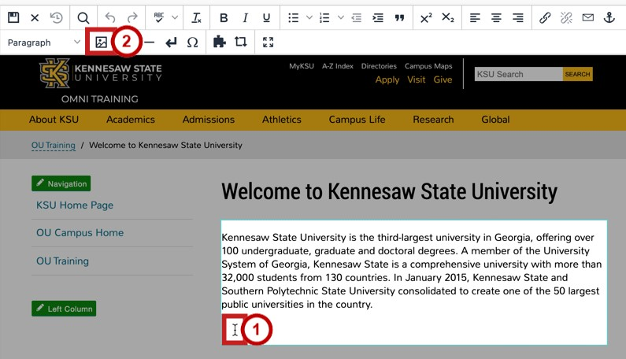

**Figure 30 – Click Insert/Edit Image Icon**

1. The *Insert/Edit Image* window will open. Click the **Source** icon.

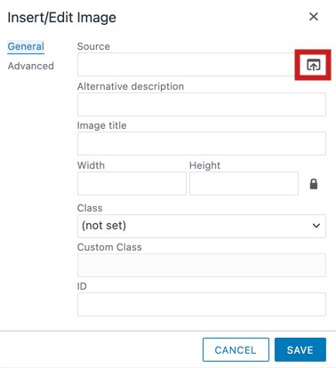

**Figure 31 – Click Source Icon**

1. The *Select Image* window will open. From here, you can either:
   1. Select a **file** from your existing files (See Figure 32).
   2. Click the **Upload** button to upload a file (See Figure 32).

**Note:** If you select an existing file, you can skip to Step 9.

**Figure 32 – Select Image or Click Upload**

1. The *Upload Image* window will open. Click the **Add** button.

**Figure**

**33**

**-**

**Click the Add Button**

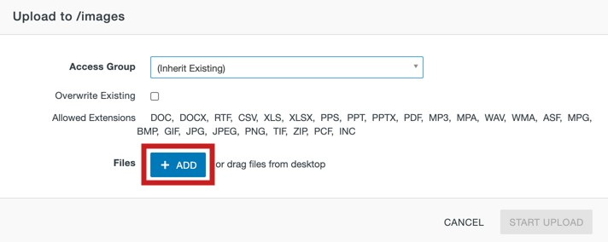

1. Navigate to and select the image you wish to upload (See Figure 34).
2. Click the **Open** button (See Figure 34).

**Figure**

**34**

**–**

**Select File & Click Open**

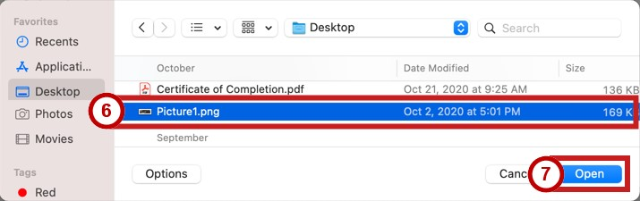

1. You will be returned to the *Upload to* window. Verify that the image name is correct and click **Start Upload**.

**Figure**

**35**

**-**

**Click on Browse**

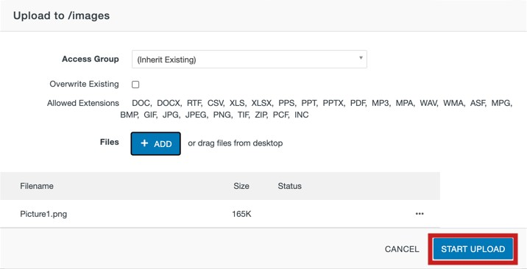

1. You will be returned to the *Select File* window, and the file will appear in the list to the left. Click **Insert.**

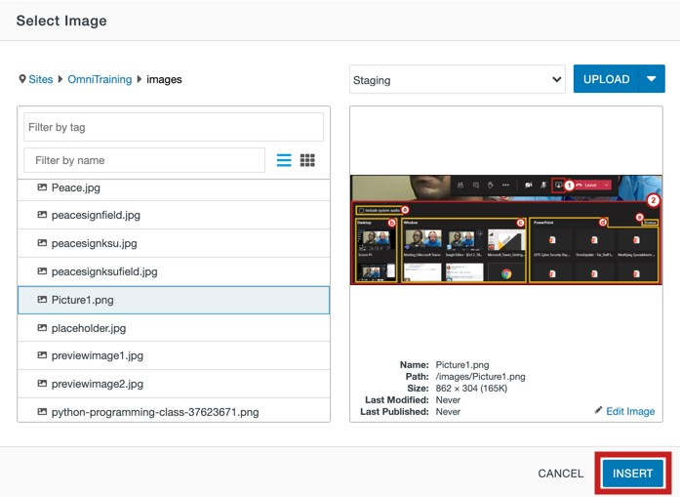

**Figure 36 - Click Insert**

1. Enter a **description** for the image in the *Alternative description*field (See Figure 37).
2. Click inside the *Class* dropdown menu to select the **relative size and placement** of the image (See Figure 37).

**Figure**

**37**

**-**

**Add a Description & Set a Class**

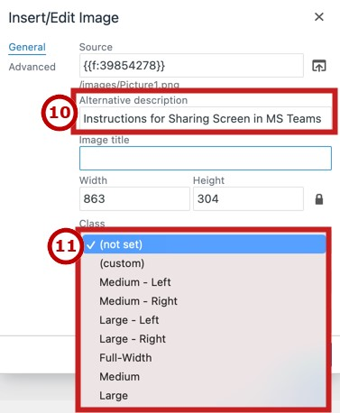

1. When you are finished with the image settings, click **Save**.

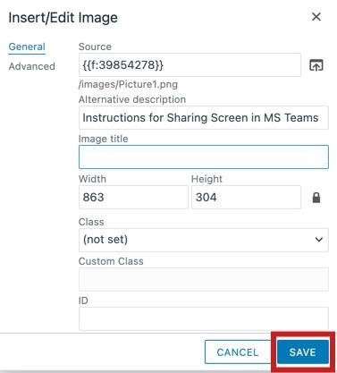

**Figure 38 - Click Save**

1. The image will be added to your page**.**

**Figure 39 – Image is Added to Page**

## Inserting YouTube Videos

The following explains how to add *YouTube* videos to your webpage:

1. Place your **cursor** where you wish to add your media (See Figure 40).
2. Click the **Insert/Edit Video** icon (See Figure 40).

**Figure**

**40**

**-**

**Place**

**C**

**ursor**

**&**

**Click Insert Video Icon**

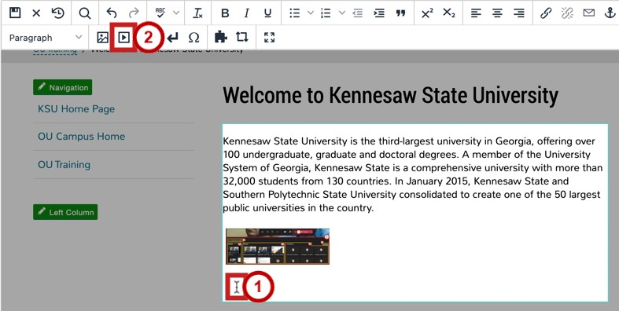

1. Open a new browser window in your preferred internet browser.
2. Navigate to [www.youtube.com.](https://kennesawedu.sharepoint.com/sites/LTAO/training/Shared%20Documents/OU%20Campus/Documentation/www.youtube.com)

1. In *YouTube,* navigate to the **video** that you wish to add.

**Figure**

**41**

**-**

**Navigate to**

**your video**



1. Copy the video link from the address bar.



**Figure 42 - Copy your address**

1. In the *Insert/Edit Embedded Media* screen, located in *Omni CMS*, paste your *YouTube* link in the **Source** field (See Figure 43).

1. Click the **Save** button (See Figure 43).

**Figure**

**43**

**-**

**Click**

**Save**

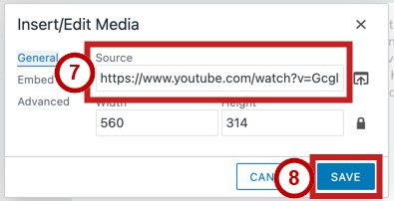

1. The **video** will appear in your webpage editor.

**Figure**

**44**

**–**

**YouTube video in Editor**

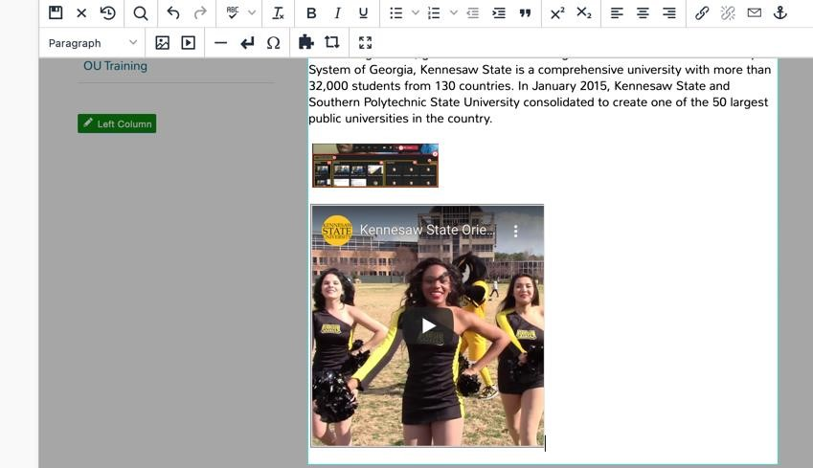

## Embedding Videos from Kennesaw State MediaSpace

*MediaSpace* is Kennesaw State’s dedicated video sharing website. When you need to upload videos to share with your audience at KSU, it is recommended that you utilize MediaSpace. For more information on using MediaSpace, please refer to the [*Getting Started with KSU’s MediaSpace: Faculty/Staff Quick Start Guide*.](https://apps.kennesaw.edu/files/pr_app_uni_cdoc/doc/Getting_Started_KSU_MediaSpace-1_rev.pdf) The following explains how to embed video from Kennesaw State University’s MediaSpace onto your website.

1. Open a new browser window in your preferred internet browser
2. Navigate to [*mediaspace.kennesaw.edu*.](http://mediaspace.kennesaw.edu/)
3. Click on the **Guest** icon.



**Figure 45 - Guest Icon**

1. lick **Login**.

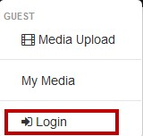

**Figure 46 - Login**

1. Enter your **NetID and NetID Password** (See Figure 47).
2. click **Sign in** (See Figure 47).

**Figure**

**47**

**-**

**NetID Login**

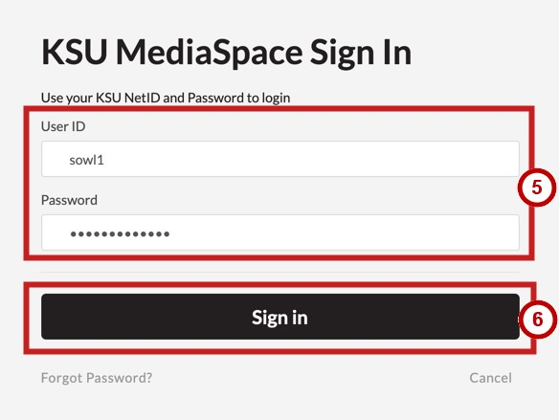

1. To upload a video that you have created, click **My Media**.



**Figure 48 – Click My Media**

8.

Click the video that y

ou wish to

**Embed**

**.**

**Figure**

**49**

**-**

**Select your Embed**

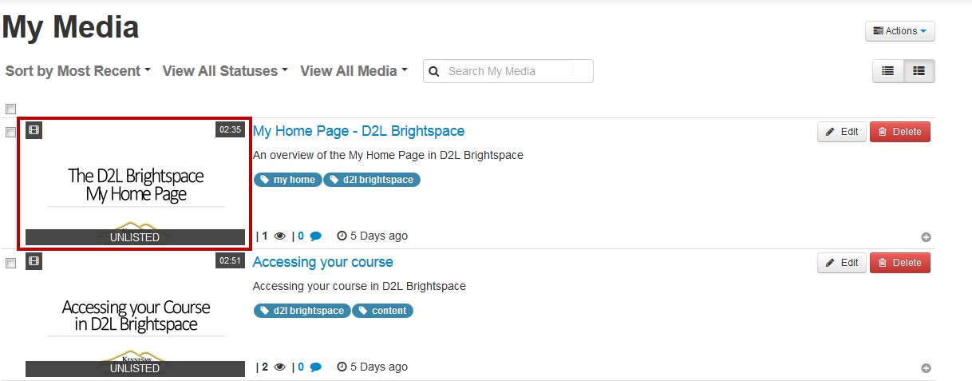

1. Click **Share**.

**Figure**

**50**

**-**

**Share Button**

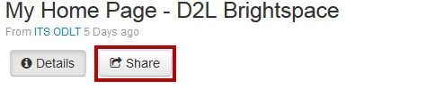

1. Click **Embed**.

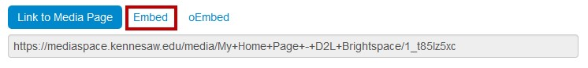

**Figure 51 - Click on Embed**

11.

Copy the

**Embed Code**

from the

*Embed*

field.

**Figure**

**52**

**-**

**Copy the Embed Code**

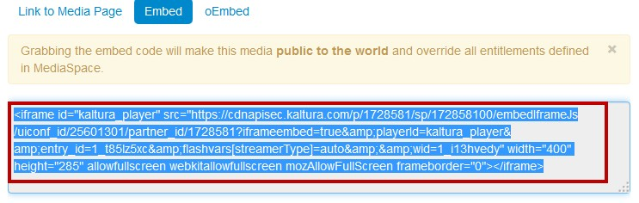

1. Place your cursor where you wish to embed your video in the *OmniUpdate* page that you are editing (See Figure 53).

1. Click the **Insert/Edit Video** button (See Figure 53).

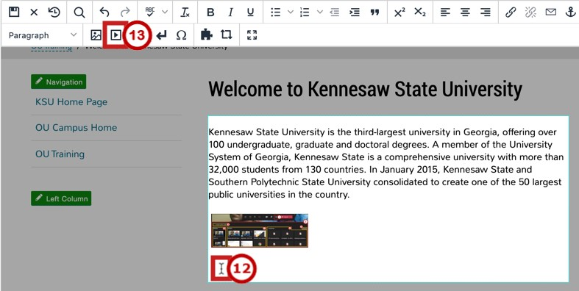

**Figure 53 - Place Cursor & Click Insert Video Icon**

1. Click the **Embed** tab (See Figure 54).
2. In the *Omni CMS* page that you are editing, paste the **Embed Code** in the *Paste your embed code below* field (See Figure 54).

1. Click **Save** (See Figure 54).

**Figure**

**54**

**–**

**C**

**lick Embed, Paste Code, &**

**Click Save**

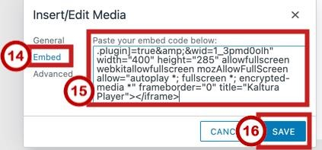

1. The video has been embedded in the page.

**Figure**

**55**

**–**

**Video has been Inserted**

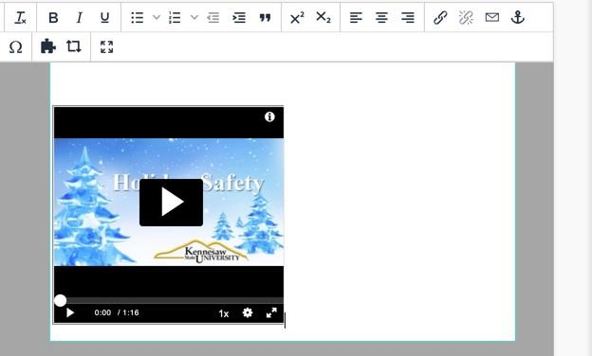

# Publishing a Page in Omni CMS

The following explains how to publish a page in Omni CMS.

1. To publish your page, click **Publish.**

**Figure**

**56**

**-**

**Click Publish**

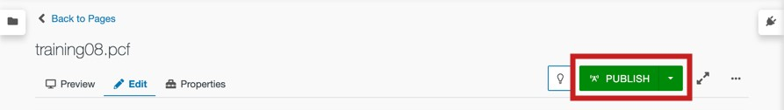

**Note:** If you have not saved your changes, the *Save and Publish* window will open. Click **Save**.

1. The *Final Check* page will appear. To scan your page for spelling and hyperlink validity, click the **Run All** button (See Figure 57).

1. Upon running your checks, you will see your error report. To view and correct any errors, click the **Error Number** link (See Figure 57).

1. If you would like to schedule the release of the publication rather than publishing immediately, click **Add Schedule** (See Figure 57).

1. If the *Include Unpublished Dependencies* section appears, leave the **checkbox** checked to publish any items on the page that have not been previously published online (See Figure 57).

1. Type any **notes** about the version in the *Version Description* text area (See Figure 57).
2. When you are finished, click **Publish** to publish the page live on web (See Figure 57).

**Figure**

**57**

**-**

**Publish Page Options**

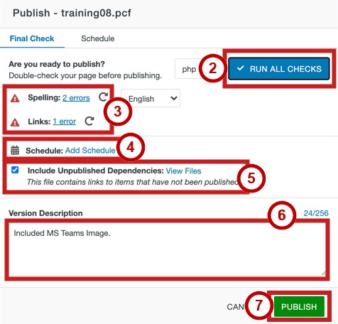

1. Once the page has been successfully published, a notification will appear in the bottom left corner of the page. Click the **View in new window** link to see and verify the page live on the web.



**Figure 58 - View Page Live on Web**

# Adding Office Hours

On the bottom of your website, you will find a space to place your Office Hours. The following explains how to edit your office hours.

1. From your webpage, click the **Multiedit** button located at the top right corner of the page.

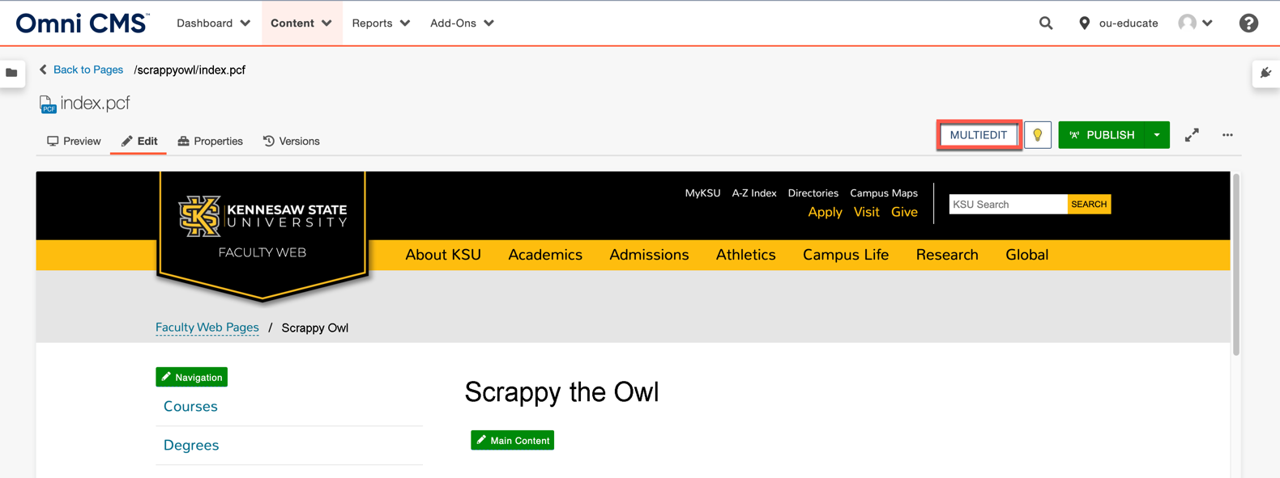

**Figure 59 – Click the Multiedit Button**

1. Enter your **office hours** in the *Office Hours* field (See Figure 60).
2. Click the **Save** button (See Figure 60).

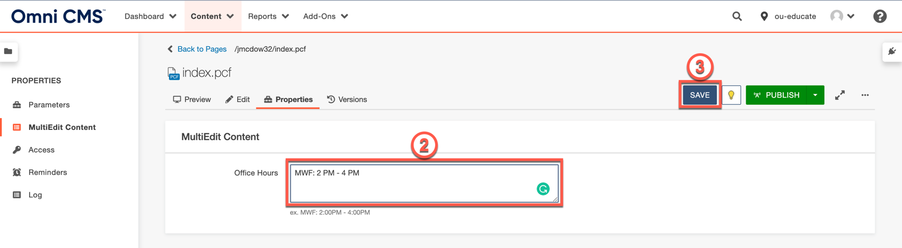

**Figure 60 – Enter Office Hours and click Save**

1. You will be taken back to your page.

**Note:** For the changes to your office hours to be visible, you must publish the page.

# Creating a New Page in Omni CMS

The following explains how to create a page in Omni CMS. **Note:** You must have at least Level 5 access in *Omni CMS* to create pages and folders.

1. In the webpage editor, click the **Content** tab (See Figure 61).
2. Click the **New** button (See Figure 61).

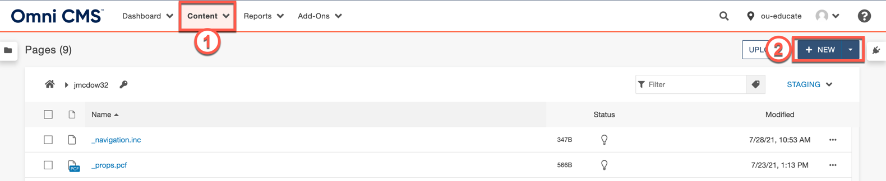

**Figure 61 – New Button**

1. Select your **Webpage** type.

**Note:** In this guide, we will be creating the *Page* type.

**Figure**

**62**

**–**

**Select**

**Webpage T**

**ype**

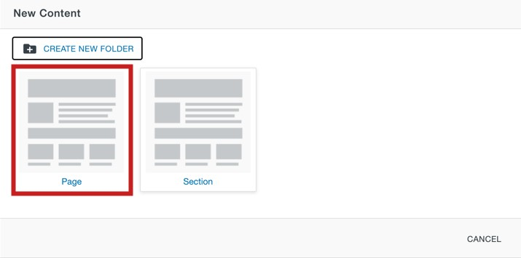

1. Enter the title of the page in the *Page Title Field* (See Figure 63)
2. Enter a brief description of the page in the *Description* field (See Figure 63). **Note**: The description will be displayed by search engines.

1. If you do not wish to add this page as to your navigation bar, select **No** in the *Add Navigation Item* dropdown (See Figure 63).

**Note:** The page will not appear in the Navigation live on the web until the Navigation file itself is published again. You can also always add the item to the Navigation at a later date.

1. Enter the **filename** for the page in the *Filename* field (See Figure 63).
2. The *Page Options* field provides options such as overwriting any existing file of the same name in the same location as well as setting who has access to edit the page (See Figure 63).

1. When you are ready to create the page, click **Create** (See Figure 63).

**Figure**

**63**

**–**

**Create**

**a Page Settings**

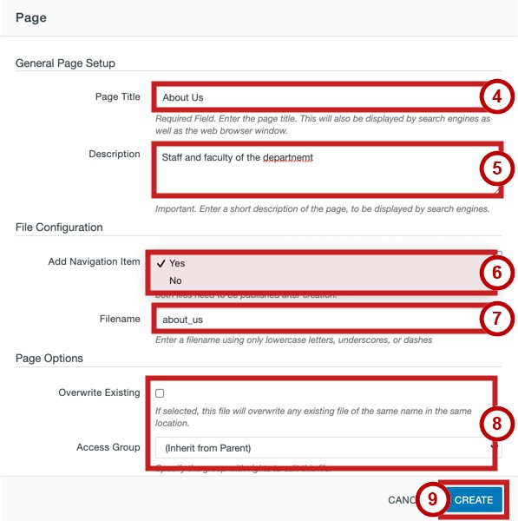

1. Your content will be created, and you will be taken to the page.

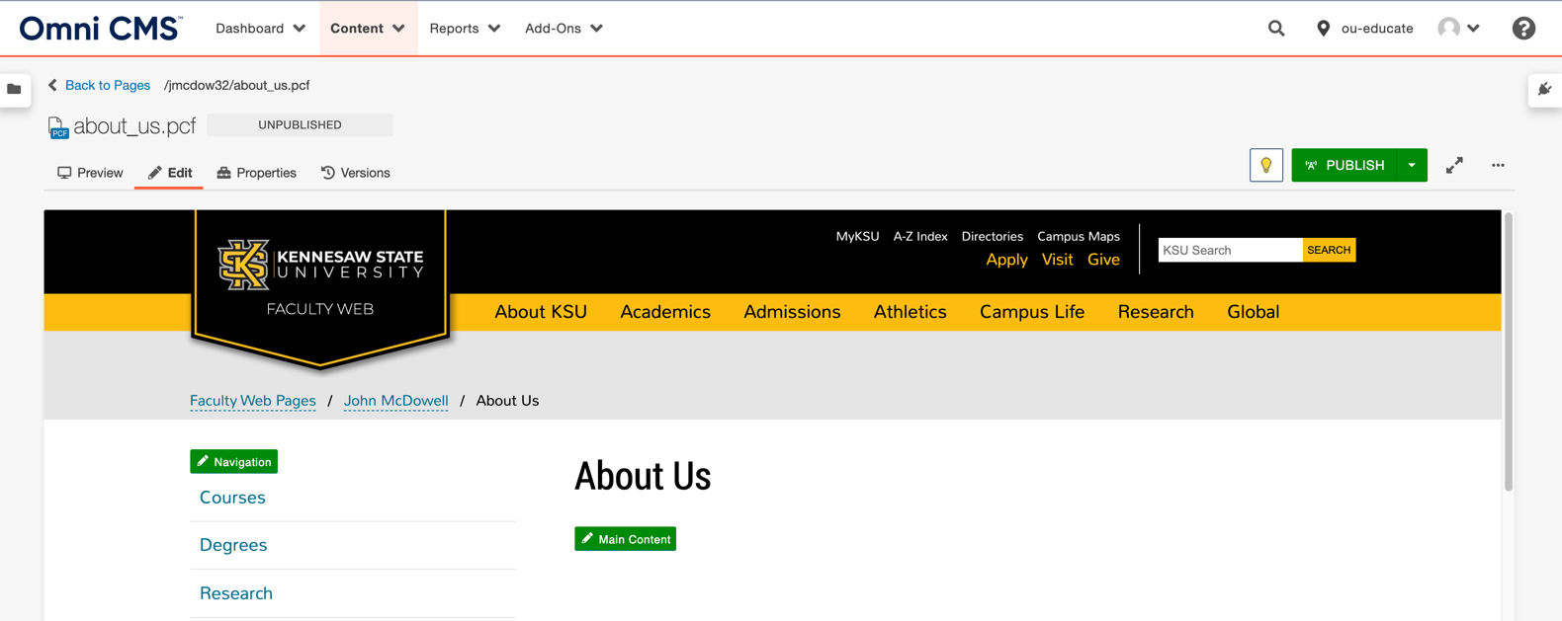

**Figure 64 – Created Content**

# Deleting Pages

The following explains how to delete web pages using Omni CMS.

1. Click **Content** (See Figure 65).
2. Locate the page that you wish to delete. Click the **File** Button (See Figure 65).
3. From the resulting dropdown menu, click **Move to Recycle Bin** (See Figure 65).

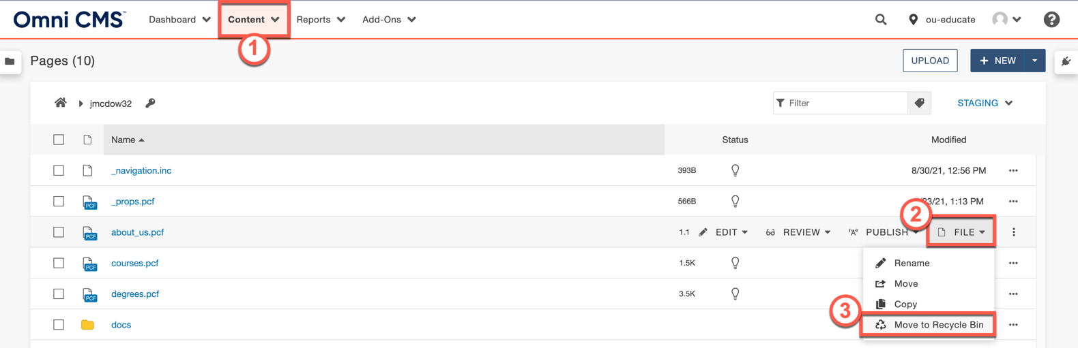

**Figure 65 – Move to Recycle Bin**

1. In the confirmation window, click **Move to Recycle Bin.**

**Figure**

**66**

**-**

**Move to Recycle Bin**

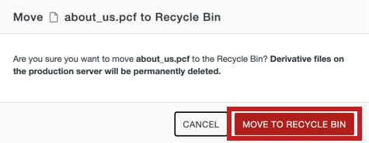

## Deleting Pages from the Recycle Bin

The following explains how to permanently delete web pages using Omni CMS.

1. Click the **Content** tab (See Figure 67).
2. In the dropdown menu, click **Recycle Bin** (See Figure 67).

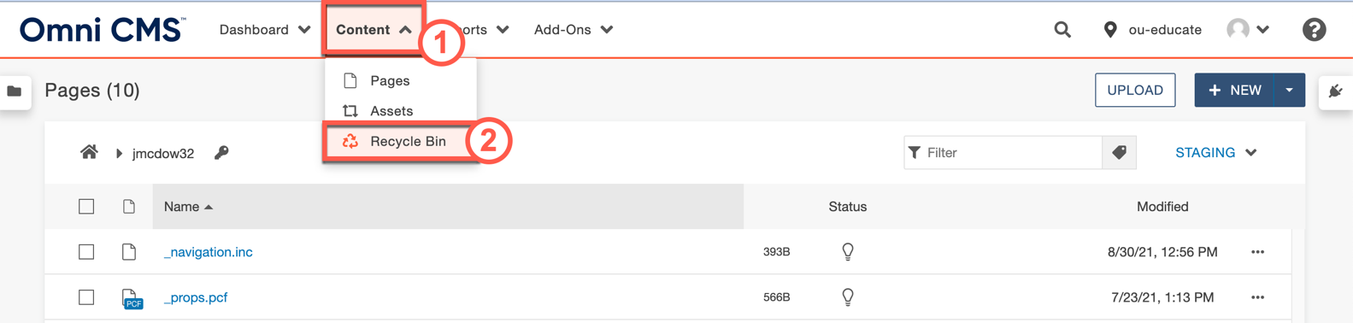

**Figure 67 – Recycle Bin**

1. Locate the page that you wish to delete. Click the **ellipses** icon (See Figure 68).
2. Click the **Delete** button (See Figure 68 ).

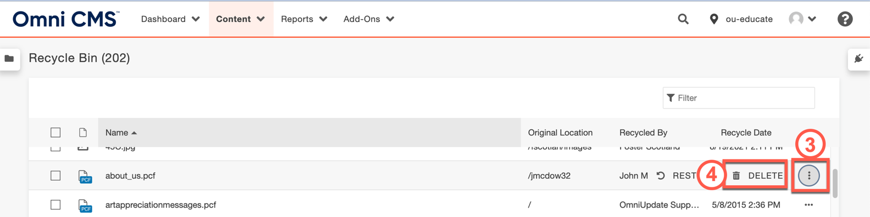

**Figure 68 – Click Ellipses and Click Delete**

1. You will be taken to the *Permanently Delete* confirmation page. To confirm that you wish to delete the page, type **delete** in the field (See Figure 69).

1. Click the **Delete** button (See Figure 69).

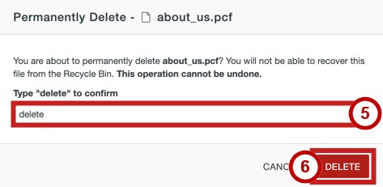

**Figure 69 - Type Delete & Click Delete**

## Restoring Pages from the Recycle Bin

The following explains how to restore a web page from the Recycle Bin using Omni CMS:

1. Click the **Content** tab (See Figure 70).
2. In the dropdown menu, click **Recycle Bin** (See Figure 70).



**Figure 70 – Click on Recycle Bin**

1. Locate the page that you wish to delete. Click the **ellipses** icon (See Figure 71).
2. Click the **Restore** button (See Figure 71).

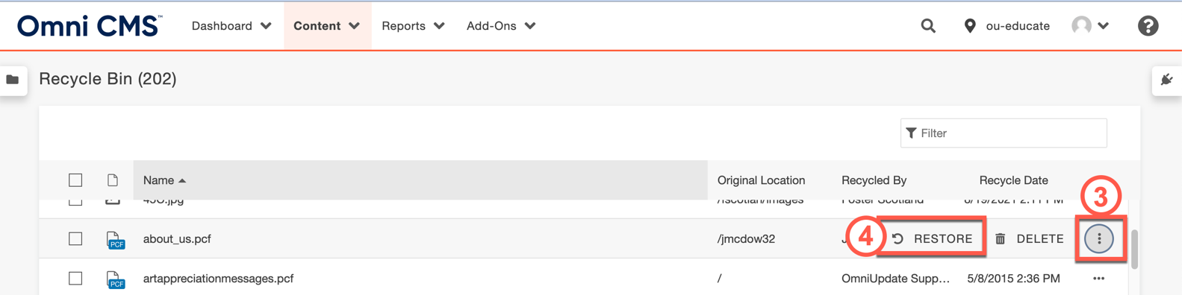

**Figure 71 – Click Ellipses and Click Restore**

1. In the confirmation window, click **Restore.**

**Figure**

**72**

**-**

**Click Restore**

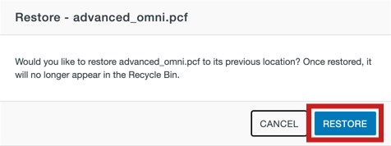

# Versioning

One of the benefits of *Omni CMS* is the ability to review and compare different versions of your edited website as well as restoring older versions of your web page should you need to roll back your changes. The following explains how to view older versions of your web page as well as revert to a previous version of the website.

## Viewing an older version of your web page

1. Navigate to the page that you wish to edit and Click the **Versions** tab.

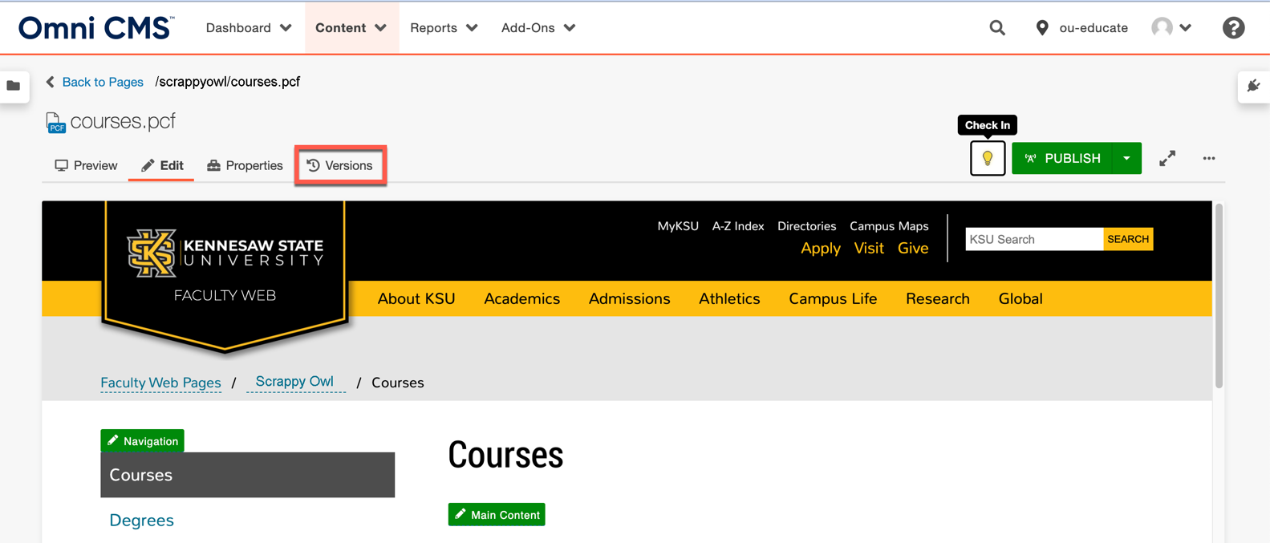

**Figure 73 – Navigate to a Page and Click the Versions Tab**

**Note:** Make sure that you have the page checked out and the lightbulb icon is yellow. If the lightbulb icon is clear, click it to check the page out. You will not see the *Versions* tab if the page is not checked out to you.

1. You will be taken to a page that documents the different iterations of the website, the date they were created, and the user who created or modified the page. To view an older version of the page, click the **ellipses** button (See Figure 74).

1. Click **View** (See Figure 74).
2. From the resulting dropdown menu, click **Page** (See Figure 74).

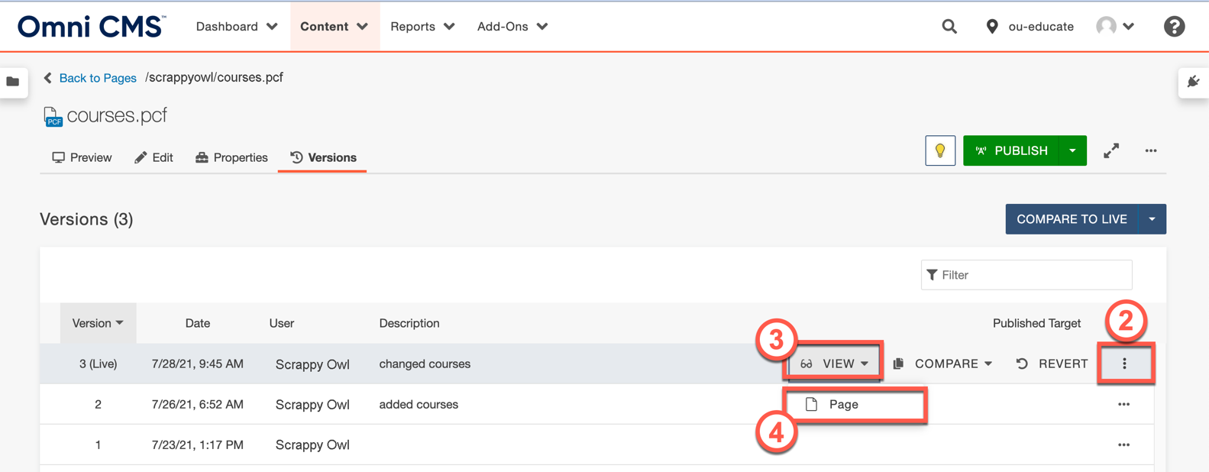

**Figure 74 – Click Ellipses and Click View**

1. You will see the older version of the webpage.

## Comparing an Older Version of the web page with the current version

1. Navigate to the page that you wish to edit and Click the **Versions** tab.



**Figure 75 – Click Versions Tab**

**Note:** Make sure that you have the page checked out and the lightbulb icon is yellow. If the lightbulb icon is clear, click it to check the page out. You will not see the *Versions* tab if the page is not checked out to you.

1. You will be taken to a page that documents the different iterations of the website, the date they were created, and the user who created or modified the page. To view an older version of the page, click the **ellipses** button (See Figure 76).

1. Click **Compare** (See Figure 76).
2. From the resulting dropdown menu, click **Page** (See Figure 76).

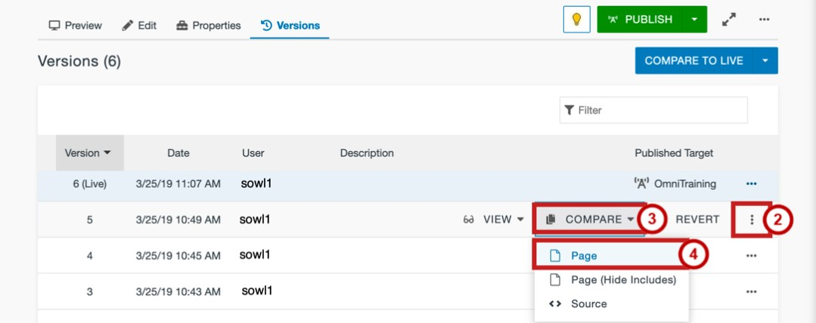

**Figure 76 – Click Compare**

1. You will be taken to the version compare window. The page will display differences between the version you selected and the current version of the page.

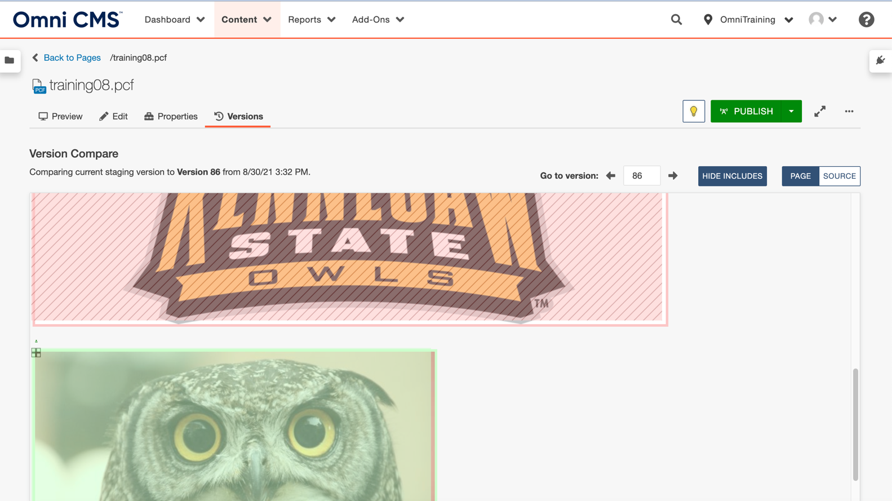

**Figure 77 – Comparing the two versions**

## Reverting to an Older Version of your web page

The following explains how to revert to an older version of your website.

1. Navigate to the page that you wish to edit and Click the **Versions** tab.



**Figure 78 – Navigate to a Page and Click the Versions Tab**

**Note:** Make sure that you have the page checked out and the lightbulb icon is yellow. If the lightbulb icon is clear, click it to check the page out. You will not see the *Versions* tab if the page is not checked out to you.

1. You will be taken to a page that documents the different iterations of the website, the date they were created, and the user who created or modified the page. To view an older version of the page, click the **ellipses** button (See Figure 79).

1. Click **Revert** (See Figure 79).

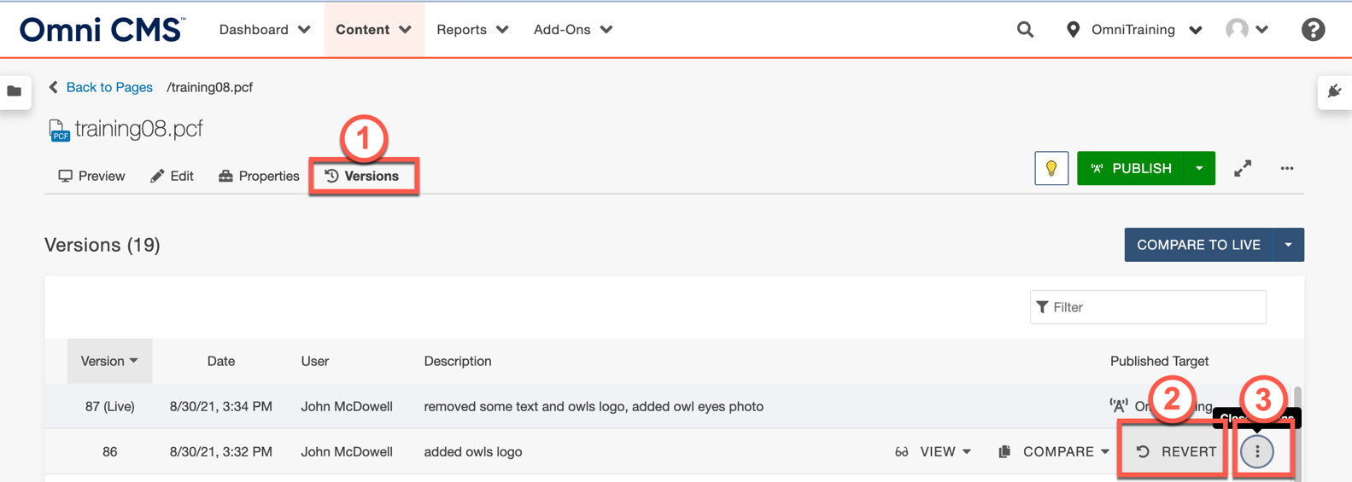

**Figure 79 - Under the Versions tab, Click Ellipses & Revert**

1. Click **Revert** in the *Confirmation Window.*

**Figure**

**80**

**-**

**Click Revert**

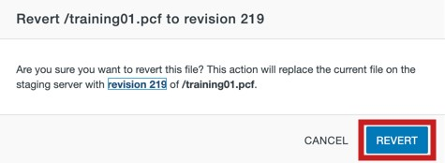

1. Your Web page will be reverted to the version you have selected. To publish the version of the page that you reverted to, click the **Publish** button.

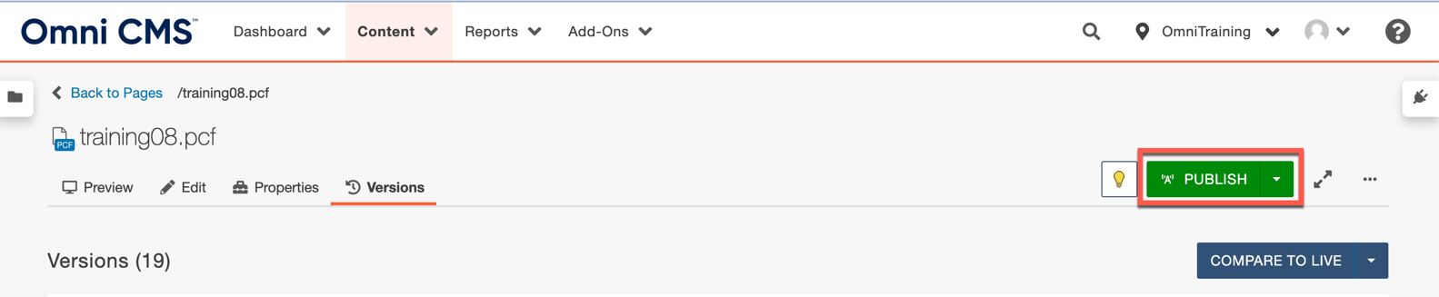

**Figure 81 - Publish**

**Note:** You must publish the reverted website version in order for the public to view it live on the web. Otherwise, it will only be reverted on the staging side.

# Editing the Navigation Bar

Omni CMS provides easy access to edit the Navigation Bar that is located to the left of your webpage. By editing the *Nav.inc* file, located in your website directory, you can add or remove links that will appear on all of your Omni CMS pages that have the Navigation Bar. The following explains how to edit the Navigation Bar.

1. Click the **Content** tab (See Figure 82).
2. From the resulting dropdown menu, click **Pages** (See Figure 82).
3. Click the **_nav.inc** file (See Figure 82).

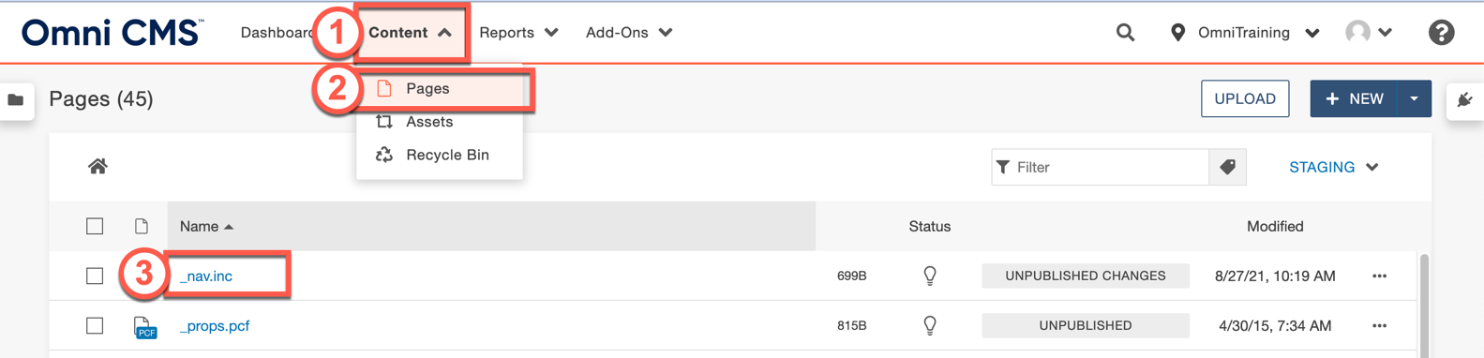

**Figure 82 – Click the _nav.inc File**

1. You will be taken to the *Navigation Bar*editor. To add a new link to the navigation bar, click inside the **editor** and click the **Enter** key on your keyboard to create a new bullet (See Figure 83).

1. Click the **Insert/Edit Link** icon (See Figure 83).

**Figure**

**83**

**–**

**Click**

**in**

**the editor**

**& Click Insert/Edit Link**

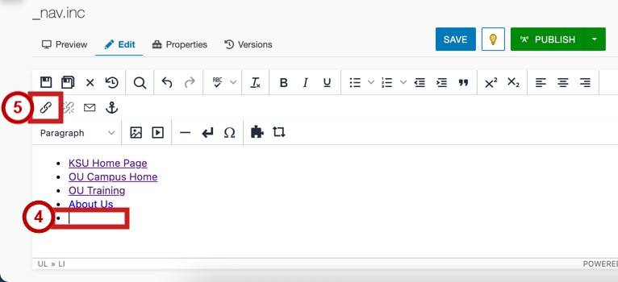

1. The *Insert/Edit Link* window will open. Click the **Source** Icon**.**

**Figure**

**84**

**-**

**Click on Browse**

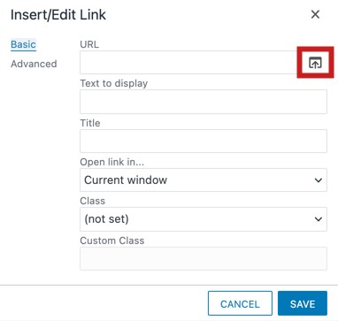

1. Click the **page** that you wish to link to (See Figure 85).
2. Click **Insert** (See Figure 85).

**Figure**

**85**

**–**

**Select File &**

**Click**

**Insert**

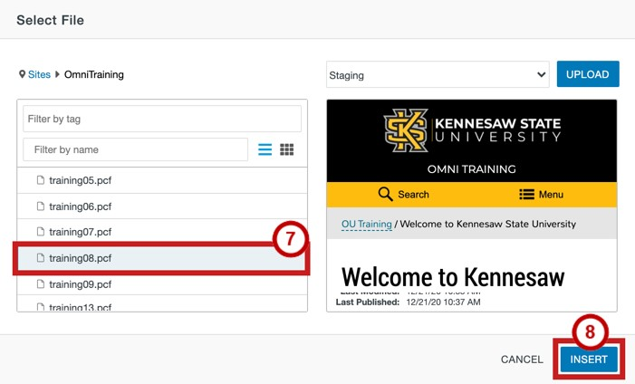

1. You will be returned to the *Insert/Edit Link* window. Enter the **text** to display in the navigation (See Figure 86).

1. In the *Open link in…* dropdown menu, select to an **option** to open the page in a new window or the current one (See Figure 86).

1. Click **Save** (See Figure 86).

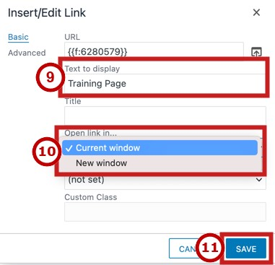

**Figure 86 - Click Insert**

1. The item has been added to the navigation. Click **Save** (See Figure 87)
2. Click **Publish** to update the page live on the web (See Figure 87).

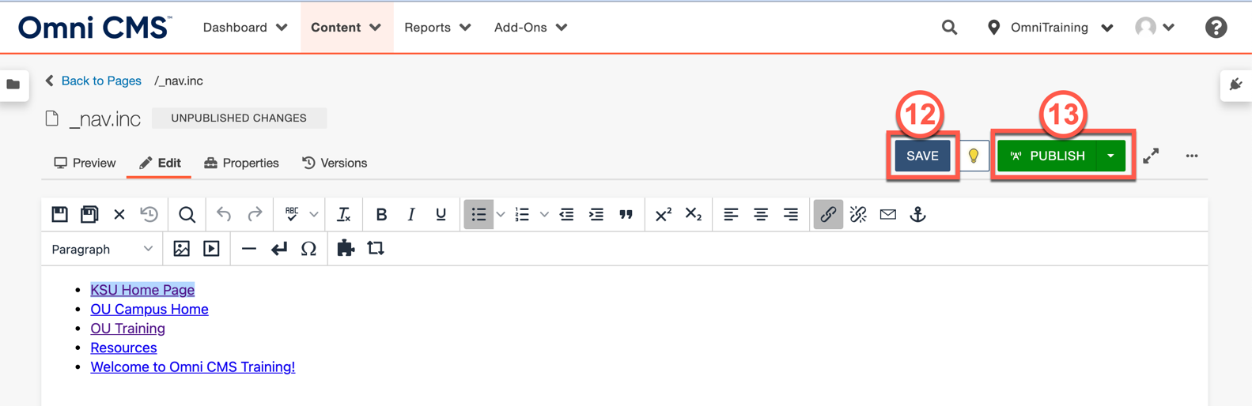

**Figure 87 – Click on Save, then Publish**

# Checking Out Pages

It is important to note that only one person can edit a webpage at a time. Therefore, when you edit a page, other users with edit rights will be unable to edit the page. This process is called “Checking In” to a page. When you have completed your edits, you must “check out” of the page so that other users may edit the page in the future. The following explains how to check out of a page that have finished editing.

# Additional Help

For additional help, please contact the *KSU Service Desk* in either of the following ways:

* **Phone:** 470-578-6999
* **Email:** service@kennesaw.edu

You can learn more about the KSU Service Desk by visiting their website:

<http://uits.kennesaw.edu/servicedesk/index.html>